1. Write a program that accepts numbers continuously as long as the number is positive and prints the sum of the given numbers.

**import** java.util.Scanner;

**public** **class** Assignment_Day_1_1 {

**public** **static** **void** main(String[] args) {

**int** num,sum=0;

Scanner sc=**new** Scanner(System.***in***);

**while**(**true**)

{ System.***out***.println("Enter numbers:");

num=sc.nextInt();

**if**(num>0)

sum=sum+num;

**else**

**break**;

}

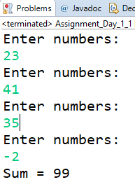 }

}

2. Write a program to accept two integers x and n and compute x raised to n.

**import** java.util.Scanner;

**public** **class** Assignment_Day_2_2 {

**public** **static** **void** main(String[] args) {

**int** x,n,res=1;

Scanner sc=**new** Scanner(System.***in***);

System.***out***.println("Enter base:");

x=sc.nextInt();

System.***out***.println("Enter power:");

n=sc.nextInt();

**for**(**int** i=1;i<=n;i++)

res=res*x;

System.***out***.println(x+" to the power "+n+" is "+res);

}

}

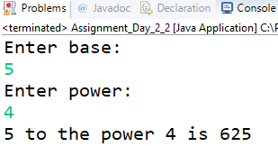

3. Write a program to accept a character, an integer n and display the next n characters.

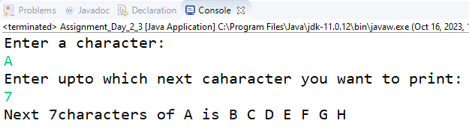

4. Write a program to calculate factorial of a number.

For e.g. factorial of 5 = 5! = 5 *4*3*2*1 = 120

**import** java.util.Scanner;

**public** **class** Assignment_Day_2_4 {

**public** **static** **void** main(String[] args) {

Scanner sc=**new** Scanner(System.***in***);

**int** fact=1,num = 0;

System.***out***.println("Enter a number of which you want factorial:");

**if**(sc.hasNextInt())

{

num=sc.nextInt();

}

**else**

System.***out***.println("Enter an integer value!!!");

**for**(**int** i=1;i<=num;i++)

fact=fact*i;

System.***out***.println("Factorial of "+num+" is "+fact);

}

}

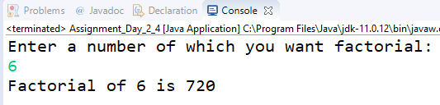

5. Write a program to calculate factors of a given number.

**import** java.util.Scanner;

**public** **class** Assignment_Day_2_5 {

**public** **static** **void** main(String[] args) {

Scanner sc=**new** Scanner(System.***in***);

**int** num = 0;

System.***out***.println("Enter a number of which you want factors:");

**if**(sc.hasNextInt())

num=sc.nextInt();

**else**

{

System.***out***.println("Enter an integer value!!!");

System.*exit*(0);

}

System.***out***.print("Factors of "+num+" are ");

**for**(**int** i=2;i<=num/2;i++)

{

**if**(num%i==0)

System.***out***.print(i+" ");

}

}

}

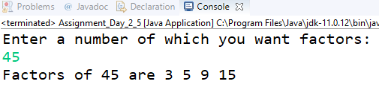

6. Accept two numbers and calculate GCD of them.

**import** java.util.Scanner;

**public** **class** Assignment_Day_2_6 {

**public** **static** **void** main(String[] args) {

Scanner sc=**new** Scanner(System.***in***);

**int** n1=0,n2=0,GCD=1;

System.***out***.println("Enter first number:");

**if**(sc.hasNextInt())

{

n1=sc.nextInt();

}

**else**

{

System.***out***.println("Enter inter value!!!");

}

System.***out***.println("Enter second number:");

**if**(sc.hasNextInt())

{

n2=sc.nextInt();

}

**else**

{

System.***out***.println("Enter inter value!!!");

}

**for**(**int** i=1;i<=(n1>n2?n1:n2)/2;i++)

{

**if**(n1%i==0 && n2%i==0)

{

**if**(i>GCD)

GCD=i;

}

}

System.***out***.println("GCD of "+n1+" and "+n2+" is "+GCD);

}

}

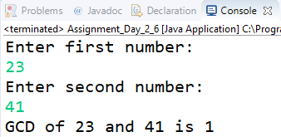

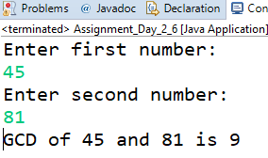

7. Write a menu driven program to do following operations :

a) Compute area of circle

b) Compute area of rectangle

c) Compute area of triangle

d) Exit

Display menu, ask choice to the user, depending on choice accept the parameters and perform the

operation. Continue this process until user selects exit option.

**BUSINESS CLASS LOGIC**

**import** java.util.Scanner;

**import** java.lang.Math;

**public** **class** Area {

**static** Scanner *sc*=**new** Scanner(System.***in***);

**public** **static** **void** circle()

{

**double** rad = 0,area;

System.***out***.println("Area of Circle:");

System.***out***.println("Enter radius:");

**if**(*sc*.hasNextInt())

rad=*sc*.nextInt();

**else**

{

System.***out***.println("Enter a valid value!!!");

}

area=3.14*rad*rad;

System.***out***.println("Area of circle = "+area);

}

**public** **static** **void** rectangle()

{

**double** len = 0,width = 0,area;

System.***out***.println("Area of Rectangle:");

System.***out***.println("Enter Length:");

**if**(*sc*.hasNextInt())

len=*sc*.nextInt();

**else**

{

System.***out***.println("Enter a valid value!!!");

}

System.***out***.println("Enter Width:");

**if**(*sc*.hasNextInt())

width=*sc*.nextInt();

**else**

{

System.***out***.println("Enter a valid value!!!");

}

area=len*width;

System.***out***.println("Area of Rectangle = "+area);

}

**public** **static** **void** triangle()

{

**double** s1 = 0,s2 = 0,s3 = 0,s,area;

System.***out***.println("Area of Triangle:");

System.***out***.println("Enter Side 1:");

**if**(*sc*.hasNextInt())

s1=*sc*.nextInt();

**else**

{

System.***out***.println("Enter a valid value!!!");

}

System.***out***.println("Enter Side 2:");

**if**(*sc*.hasNextInt())

s2=*sc*.nextInt();

**else**

{

System.***out***.println("Enter a valid value!!!");

}

System.***out***.println("Enter Side 3:");

**if**(*sc*.hasNextInt())

s3=*sc*.nextInt();

**else**

{

System.***out***.println("Enter a valid value!!!");

}

s=(s1+s2+s3)/2;

area=Math.*sqrt*((s*(s-s1)*(s-s2)*(s-s3)));

System.***out***.println("Area of Triangle = "+area);

}

}

**IMPLEMENTATION**

**import** java.util.Scanner;

**public** **class** Assignment_Day_2_7 {

**public** **static** **void** main(String[] args) {

Scanner sc = **new** Scanner(System.***in***);

**int** ch = 0;

**do** {

System.***out***.println("1.Area of Circle\n2.Area of Rectangle\n3.Area of Triangle\n4.Exit");

System.***out***.println("Enter your choice:");

**if** (sc.hasNextInt()) {

ch = sc.nextInt();

}

**else** {

System.***out***.println("Enter an integer value!!!");

}

**switch** (ch) {

**case** 1:

Area.*circle*();

**break**;

**case** 2:

Area.*rectangle*();

**break**;

**case** 3:

Area.*triangle*();

**break**;

**case** 4:

System.***out***.println("Program Terminated Successfully!!!");

System.*exit*(0);

}

} **while** (ch != 4);

}

}

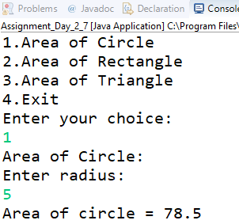

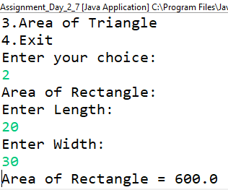

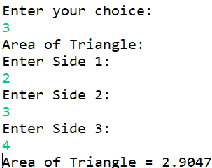

8. Write a program to print all prime numbers between 1 to n

**import** java.util.Scanner;

**public** **class** Assignment_Day_2_8 {

**public** **static** **void** main(String[] args) {

Scanner sc=**new** Scanner(System.***in***);

**int** num = 0,count;

System.***out***.println("Enter th range:");

**if**(sc.hasNext())

{

num=sc.nextInt();

}

**else**

{

System.***out***.println("Enter an integer value!!!");

System.*exit*(0);

}

**for**(**int** i=2;i<=num;i++)

{

count=0;

**for**(**int** j=1;j<=i;j++)

{

**if**(i%j==0)

count++;

}

**if**(count==2)

System.***out***.print(i+" ");

}

}

}

